~Asia-China-Mirror Han-Ch'ien Chi'iu-Thousand Autumns

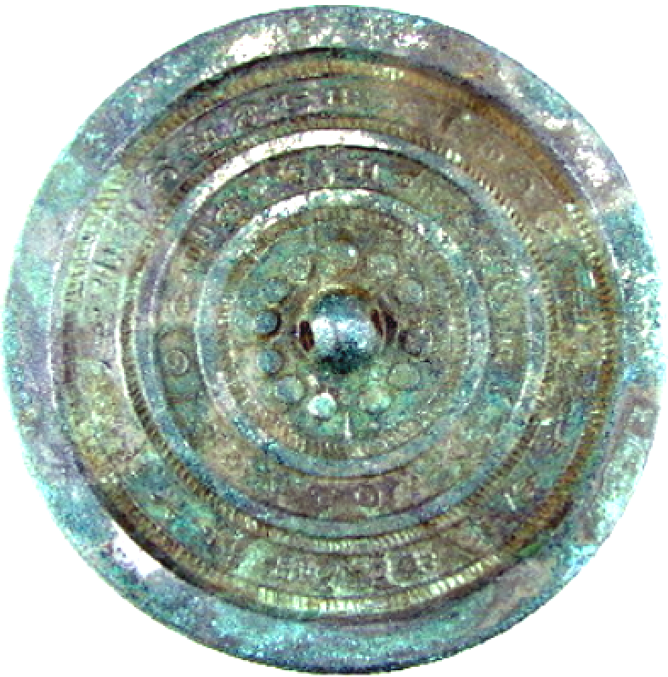
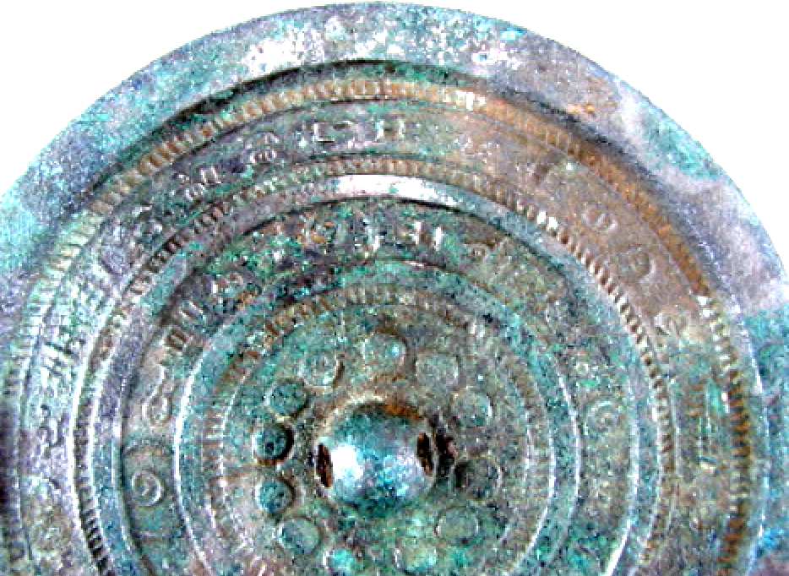
Locality: Loyang.
Diameter: 14.4 cm.
Inscription in inner circle:
Like the light of the Sun and the Moon
May our memory of each other be everlasting.
The outer circle has archaic characters, difficult to decipher.
Reference: Robert W. Swallow, Ancient Chinese bronze mirrors. Rev. and enlarged ed. by Fred Belcher. Ann Arbor: Ars Ceramica, Ltd., 1977, Fig. 30.
In the Han period a great interest was paid to inscribing mirrors with literary flourishes by well-known bronze smiths of the age. These inscriptions often had the names of the bronze smiths themselves emblazoned on the mirrors to identify them as having been produced by private ateliers and not produced by the Imperial factories. This mirror has the outer circle of inscriptions in the ancient Shang script which may indicate the atelier's name and location. The inner circle of inscriptions indicates the purpose of the mirror for the person who commissioned it, probably for a spouse or lover.

